************************************************ *please do not write below this line* **************************************************

***Practitioner’s notes:***

*client’s health history:*

*contraindications / restrictions / precautions:*

*client likes / dislikes:*

*remarks:*

Thai Healing Alliance International  www.ThaiHealingAlliance.com

|  |  |  |  |
| --- | --- | --- | --- |
| ***date*** *(d-m-y)* |  | ***total session time*** |  |
| *Second session notes* | | | | |

|  |  |  |  |
| --- | --- | --- | --- |
| ***date*** *(d-m-y)* |  | ***total session time*** |  |
| *First session notes* | | | | |

*Practitioner’s notes:*

*Client consent and agreement — Please read and sign below*

* *It is agreed and understood that Thai therapy is intended for relaxation, and that it is not meant to diagnose, treat or remedy any illness, disease, injury, physical condition or mental disorder.*
* *Except in cases of emergency, I agree to pay for all sessions which are not cancelled at least 24 hours in advance.*
* *Traditional Thai massage is strictly non-sexual. Under extenuating circumstances, either party reserves the right to immediately terminate the session.*
* *I understand that the practice of all forms of body therapy are subject to local laws and ordinances.*

*signature ___________________________________________________ date ______________________*

*\*\*\*\*\*\* please do not write below this line \*\*\*\*\*\**

*Do you have any restrictions in movement?* ________________________________________________________________

*Are there any movements or stretches you think may be harmful*?_______________________________________________

*Do you generally like to hear music during a session? ________________________________________________________*

*Is it OK to use lightly scented lotion or balm on your face? _____________________________________________________*

*Do you have any other comments or requests? ______________________________________________________________*

*page 2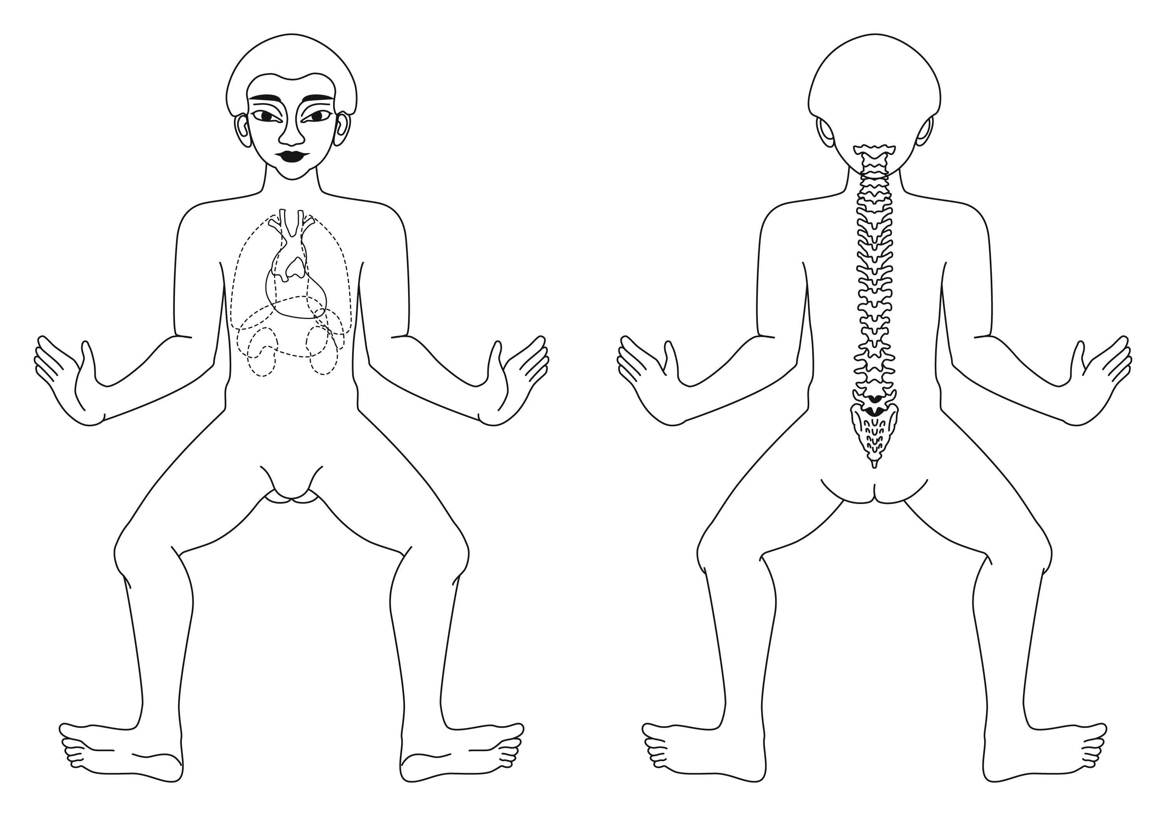*

***continued next page..***

*On the diagrams to the right, circle any problem areas, and indicate as follows:*

tension **“T”**

pain **“P”**

surgeries **“S”**

*name* ____________________________________________________________________ *date*________________________

*home tel: ______________________________ work tel: ________________________ e-mail: ____________________________*

*address: _____________________________________________________ __________________________ _________________*

*date of birth: _____________________ profession: ________________________ referred by: ______________________________*

*emergency contact info: ______________________________________________________________________________________*

*are you currently taking medication? _____________________________________________________________ ______________*

*describe any special medical conditions: _________________________________________________________________________*

*__________________________________________________________________________________________________________*

*indicate if any conditions apply: _____ surgeries _____ spinal / disc problems _____ heart problems _____ high blood pressure*

*______ osteoporosis ______ hernia ______ fractures ______ arthritis ______ user contact lenses _____ pregnancy*

*_____ back pain _____ neck pain ______ constipation ______ diarrhea ______ other: _ _ _ _ _ _ _ _ _ _ _ _ _ _ _ _ _ _ _*

*Please describe more fully any of the above conditions:*

***Confidential Client Information Form***