page 2
************************************************ please do not write below this line **************************************************

Practitioner’s notes:

client’s health history:

contraindications / restrictions / precautions:

client likes / dislikes:

remarks:

Thai Healing Alliance International  www.ThaiHealingAlliance.com

Do you have any restrictions in movement? ________________________________________________________________

Are there any movements or stretches you think may be harmful?_______________________________________________

Do you generally like to hear music during a session? ________________________________________________________

Is it OK to use lightly scented lotion or balm on your face? _____________________________________________________

Do you have any other comments or requests? ______________________________________________________________
Client consent and agreement — Please read and sign below

- It is agreed and understood that Thai therapy is intended for relaxation, and that it is not meant to diagnose, treat or remedy any illness, disease, injury, physical condition or mental disorder.

- Except in cases of emergency, I agree to pay for all sessions which are not cancelled at least 24 hours in advance.

- Traditional Thai bodywork is strictly non-sexual. Under extenuating circumstances, either party reserves the right to immediately terminate the session.

- The practitioner is a Registered Thai Therapist (RTT) in the Thai Healing Alliance, however the practice of all forms of body therapy are subject to local laws and ordinances.

signature ___________________________________________________ date ______________________

****** please do not write below this line ******

Practitioner’s notes:
date (d-m-y) |  | total session time
First session notes

date (d-m-y) |  | total session time
Second session notes

Attach THAI Form N for additional therapy session notes for this client

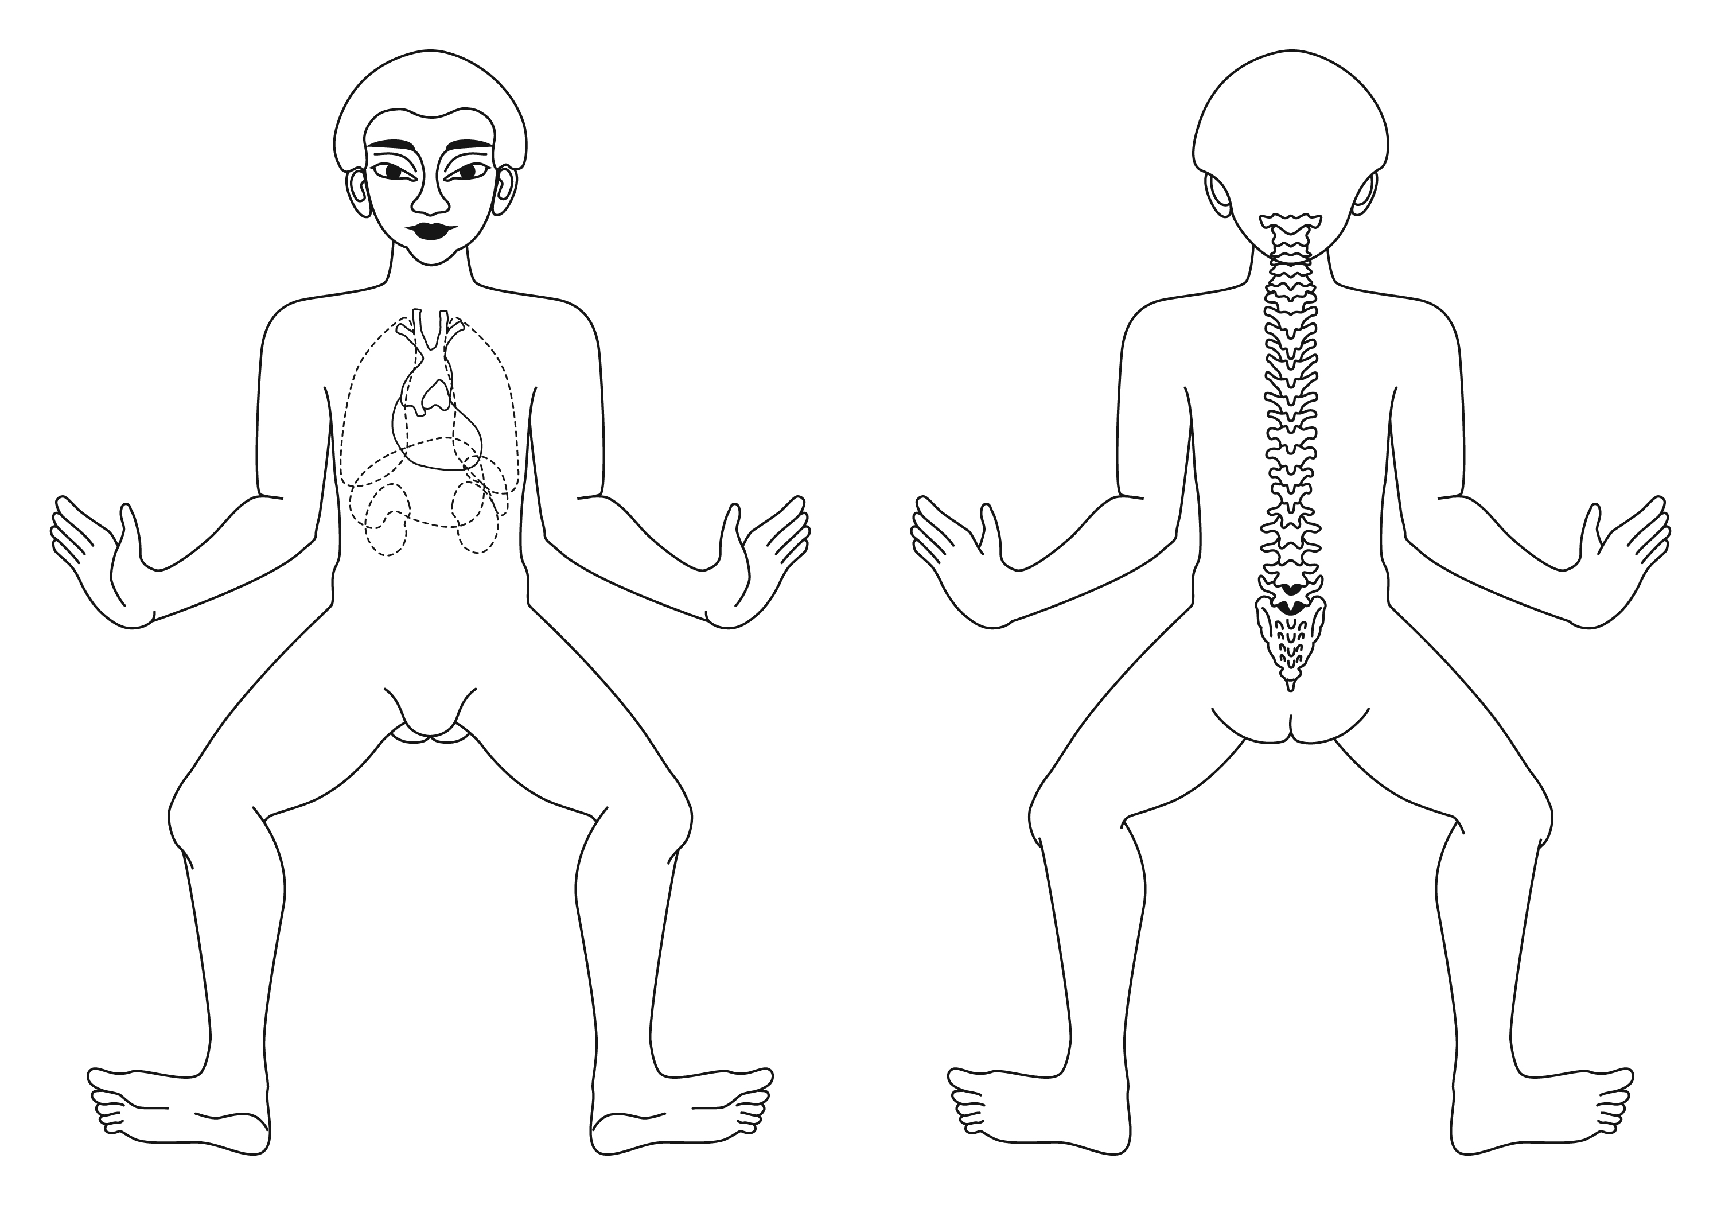

name ____________________________________________________________________ date________________________

home tel: ______________________________ work tel: __________________________ e-mail: _______________________________

address: ________________________________________________________ __________________________ ____________________

date of birth: _____________________ profession: ___________________________ referred by: _________________________________

emergency contact info: ____________________________________________________________________________________________

are you currently taking medication? __________________________________________________________________________________

describe any special medical conditions: _______________________________________________________________________________

________________________________________________________________________________________________________________

indicate if any conditions apply: _____ surgeries _____ spinal / disc problems _____ heart problems _____ high blood pressure

______ osteoporosis ______ hernia ______ fractures ______ arthritis ______ wear contact lenses ______ pregnancy

______ back pain ______ neck pain ______ broken bones / fractures ______ constipation ______ diarrhea ______ other

describe more fully any of the above conditions:

Confidential Client Information Form

On the diagrams to the right, circle any problem areas, and indicate as follows:

tension “T”
pain “P”
surgeries “S”
continued next page..

